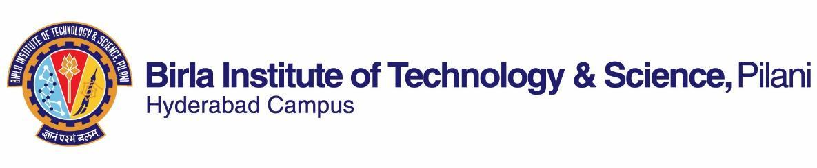

**FIRST SEMESTER 2022-2023**

# Course Handout Part II

29-08-2022

In addition to part I (General Handout for all courses appended to the time table) this portion gives further specific details regarding the course.

*Course No*. : HSS F332

*Course Title* : Cinematic Art

*Instructor-in-charge* : Spandan Bhattcharya

**Scope and Objectives of the course:**

This course presents the key elements for the study of cinema, beginning with establishing formal aspects of cinema by explaining terms such as ‘film space’, ‘film time’, ‘mise-en-scene’, various kinds of shots and editing techniques while drawing upon cinematic examples across the world. It sets the stage for students to acquaint themselves with the required filmic vocabulary and idioms to perform textual analysis of films. This course proposes to expose students to divergent cinematic styles and culturally and politically formed modes of expression.

The course also introduces various modes and methods of film criticisms while familiarizing students with critical cinematic concepts like auteur theory etc. The course combines analysis of textual form with an engagement with historical context and the materials that have been crucial to the production, distribution, reception and consumption of the text. And the course’s understanding of cinema is one that is dispersed across other arts and mediums which include painting, music, drama etc.

**Objectives:** The course aims tofamiliarize students with the various filmic vocabularies and idioms and numerous approaches of understanding cinema.It will enable them to position and understand the elements of cinema as globally circulating media forms while becoming aware about the history of this medium.It will **i**ntroduce some of the key critical cinematic concepts for the study of cinema.

**Textbook:**

1. Bordwell, David, and Kristin Thompson, eds. *Film Art: An Introduction (Eleventh Edition). New York: McGraw-Hill, 2012.*

**Reference Books:**

1. Bazin, Andre. *What is Cinema? Vol. I & II.* Trans. Hugh Gray. Berkeley and Los Angeles: University of California Press, 2005.
2. Monaco, James *How to Read a Film,* New York: Oxford University Press, 2000.
3. Duggal Vebhuti, Bindu Menon and Spandan Bhattacharya ed. *Film Studies: An Introduction.* Delhi: Worldview, 2022.

**Course Plan:**

|  |  |  |  |
| --- | --- | --- | --- |
| **Lecture No.** | **Learning objectives** | **Topics to be covered** | **Chapter in the Text Book** |
| 1 | Comprehend course objectives and material | Course objectives, textbook and reference book | Course Handout |
| 2-4 | Know about the emergence of cinematic medium and its development | Early cinema and film art: From PMR to IMR | Text book, Part 3 |
| 5-8 | Discuss early modernist film movements | Early avant garde: Focus on Soviet Montage and German Expressionism | Text book,  Part 6 |
| 9-12 | The development of classical Hollywood cinema (focus on studio economy, film genres and style) | Classical Hollywood Cinema (Form, Economy, Style) | “An Excessively Obvious Cinema” by David Bordwell, Janet Staiger and Kristin Thompson |
| 13-16 | Discuss basic aspects of film language | Film space, form and style | Text book: part 2- 2 & 3;  R 3, chapter 1 |
| 17-18 | Acquaint oneself with the concepts of film time and cinematic narration | Plot, story, time: point of view and narrative | Lecture notes and text book,  part 2 |
| 19-20 | Acquire a vocabulary to discuss film sound and the difference between different kinds of film sound | Film sound: aesthetics, technology and style | Text book, part 3;  R 3, chapter 2 |
| 21-23 | Discuss late modernist film movements | Post-war European film movements: Focus on Italian Neorealism | *“*Some Ideas on the Cinema*”* by Cesare Zavattini  &  “The Birth of a New Avant Garde: La Camera Stylo” by Alexandre Astruc |
| 24-27 | Discuss Auteur Studies with reference to French New Wave and its later development | Auteur theory (Case Studies: Alfred Hitchcock and Pedro Almodóvar ) | Selection from “Notes on the Auteur Theory in 1962” by Andrew Sarris. |
| 28-30 | Discuss New Hollywood Cinema | The transition from Classical Hollywood to New Hollywood and few important films | TBA |
| 31-33 | Discuss New Danish Cinema (Dogme 95) | Dogme 95 as a film movement and its notable films | Selections from *Politics as Form in Lars Von Trier: A Post- Brechtian Reading* by Angelo Koutsourakis |
| 34-36 | Discuss cinemas from the non-west: Japanese cinema | Early Japanese film history with a focus on its key genres and film auteurs | Selections from *To the Distant Observer: Form and Meaning in Japanese Cinema* by Noel Burch |
| 37-39 | Discuss cinemas from the non-west: Latin American cinema | Latin American Cinemas: Focus on Third Cinema | “Towards a Third Cinema” by Fernando Solanas and Octavio Getino |
| 40-41 | Acquaint oneself with the transition of cinematic medium from celluloid to digital | Cinema goes digital: film art in the age of streaming platforms and OTT releases | “Beyond Netflix and Amazon: Mubi and the Curation of On-Demand Film” by Roderik Smits and E. W. Nikdel |
| 42 | Review and sum-up the course |  | ---- |

**Evaluation Scheme:**

|  |  |  |  |  |
| --- | --- | --- | --- | --- |
| **Component** | **Duration** | **Weightage**  **(%)** | **Date & Time** | **Nature of Component** |
| Assignments | TBA | 30 | TBA | Open Book |
| Mid semester Test | 90 minutes | 30 | 01/11 3.30 - 5.00PM | Closed Book |
| Comprehensive Exam | 3 hours | 40 | 21/12/2022 AN | Closed Book |

**Chamber Consultation Hours:** The timings for consultation meetings will be shared on CMS.

**Notices:** Notices concerning the course will be displayed on CMS or other online teaching platforms as notified.

**Make-up Policy:** Make-up exams and make-up assignments will be granted due to medical reasons if students have prior clearance from institute authorities and if students have informed the instructor beforehand. If a student has an extraordinary situation that does not allow him/her to appear/ for the examination/submit an assignment, the student is responsible for intimating the matter to the instructor at the earliest.

**Academic Honesty and Integrity Policy**: Academic honesty and integrity are to be maintained by all the students throughout the semester and no type of academic dishonesty is acceptable.

Spandan Bhattacharya

**INSTRUCTOR-IN-CHARGE**